710Captain (H100) Operations Manual
This operations manual describes the processes and procedures necessary to unpack, install, operate, and maintain a (hydraulic) 710Captain Capping Machine.
*INSTRUCTIONS ARE FOR REFERENCE ONLY*
Scheduling a remote installation and training session with Convectium support prior to operation is required. The below procedures should never be performed without consulting with a Convectium representative first. Failure to do so may void your warranty. Please email engineering@convectium.com, or call 1-949-343-1161, to set up an appointment.

I) Uncrating & Installation
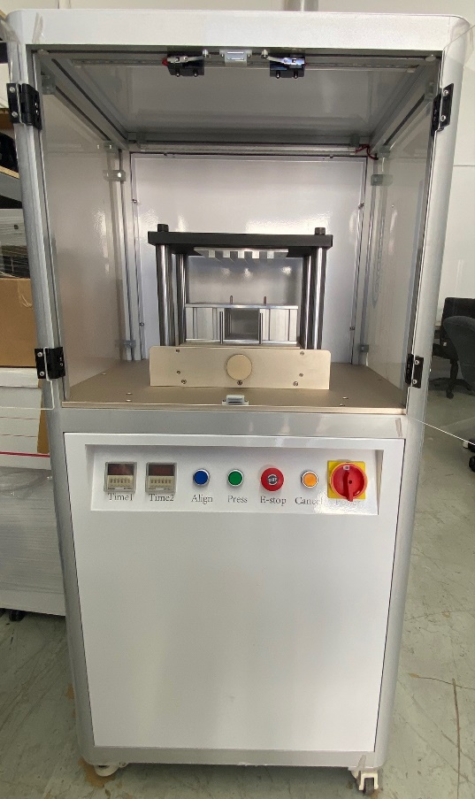
Begin by preparing the area in the manufacturing facility where the 710Captain is to be installed. The area should be level and have at least 1m (3ft) clearance in front to allow for the 710Captain doors to open. Ensure the area is located within 1.5m (5ft) from an electrical outlet (NEMA5-15R,110v AC, single phase).

A. Unboxing Checklist:
1 – 710Captain capping machine
1 – Riser block (installed)
1 – 5-bar press plate (installed)
1 – Accessory Box, which includes:
1 – AC power cord (NEMA 5-15P to IEC320C13)
1 – Flat (black) top press plate
2 – Aluminum (thick & thin) press plates
1 – Bag of 15A fuses

B. Materials Needed:
- Box cutter
- Crowbar
- Bubble level
- Calipers
- Screwdrivers

C. Procedure:
- Using a crowbar, carefully remove the top of the wooden shipping container, and set it aside. *CAUTION: There may be exposed nails on both the removed top and the shipping container.
- The crate should be shipped in an upright position. But if it’s not, perform a 2 (or more) person lift to stand the 710Captain to its proper upright position while still in its shipping container.
- Using a box cutter, cut the plastic strip that secures the 710Captain to the shipping container, before removing and throwing it away.
- Carefully wheel the 710Captain out of the shipping container and onto a level floor.
- Wheel the 710Captain to its predetermined installation location, then lower each of the four feet by spinning the wheel lock (red cog) counterclockwise until each wheel is off the ground, and the 710Captain is immobile and level.
- Remove the thin plastic film that covers the 710Captain windows & doors.
- Open the front transparent doors. Visually inspect the outside and inside of the 710Captain for any obvious shipping damage.
- Cut to remove the zip ties that secure the Accessory Box to the riser block of the press. Remove any plastic wrap and locate the power cord inside the Accessory Box to plug to the left side of the 710Captain.
- Be sure to plug the power cord to a properly wired and properly grounded NEMA 5-15R (110v AC, single phase) outlet.
- Power on by turning the red power switch clockwise, to the ‘ON’ position. The white LED lights will remain on while the 710Captain is powered on.

II) Safety Concerns

A. WARNING! Crush Hazard. Moving parts can entangle, pinch, or cut you, causing death or serious injury. Before operating this machine in anyway, you must verify that all body parts, long hair, and clothes are clear of the machine's extent of motion.

B. WARNING! Electrocution Hazard. Points in the electrical cabinet contain high voltages, which can electrocute or shock you, causing death or significant injury. Even after the machine is powered off, electronic devices in the electrical cabinet can retain dangerous electrical voltages. Use caution when servicing the machine inside the electrical cabinet.

C. Personal Protective Equipment

Always wear protective safety eyewear. Before operating this machine in anyway, you must verify that your eyewear is impact-resistant and rated for ANSI 787+.

D. Operator Knowledge

Before operating this machine in any way, you and all other operators must read and understand all instructions. If you do not, there is a risk of voided warranty, property damage, injury, or death. (*Scheduling a remote installation and training session with the Convectium support team prior to operation is required. Please submit a help desk ticket, call 949-343-1161, or email engineering@convectium.com to set up an appointment.)
- Keep the work area clean and free of clutter. Machine motion can occur if controls are accidentally activated while the machine is powered on.
- Never allow the machine to run unattended.
- Never leave tools or other loose items inside the machine.
- Never operate the machine with the electrical cabinet door open.
- Never operate the machine with the pressing area doors open.
- Never reach into the pressing area while the machine is operating.
- Never modify, defeat, or bypass safety devices or interlocks.
- Never obstruct the Emergency Stop button or any other controls.
- Never operate the machine while tired or otherwise impaired.
- Never allow untrained operators to install, operate, or maintain the machine.

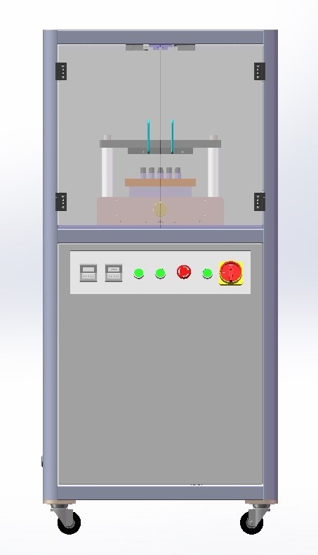
III) Inspection

A. Features & their functions:
- Power dial – Turn the big red dial a quarter turn to the right to power on.
- Cancel button – Pushing this button will bring the top plate back up to its original position.
- E-Stop button – In case of emergency, you can press this button to immediately stop the machine. To reset, rotate the STOP button clockwise
- PRESS button – Begins the pressing process to which caps the devices.
- ALIGN button – Begins the aligning (calibration) process of lowering the pressing plate to the desired height of your first device. (Hack: You can set the Align function to the height of cartridges & set the Press function to the height of disposables to maximize time efficiency).
- Time1 (ALIGN timer) – This time relay (right side of left timer) controls the amount of time that the top pressure plate presses down. Once the time expires, or max pressing height (130mm @ 3.7 seconds) is reached, the top pressure plate idles before automatically rising to the original position
- Time2 (PRESS timer) – This time relay (right side of right timer) controls the amount of time that the top pressure plate presses down.
- Top pressure plate – The flat black top plate comes stock and is commonly used for most generic devices. To cap C-cells, which require more pressure, we developed and install a 5-bar press plate prior to shipping. This is the top pressing plate that lowers and presses C-cell devices. (I.E. For a tray of 100 cartridges, you would have to press once then turn the tray 180° to align the other offset columns of carts to press again to fully cap all 100).
- Adjustable bottom pressure plate (with removable riser block sitting on top) - This is the bottom pressure plate, which can move up and down via the bottom pressure plate lifting adjustment knob. The height can be fine-tuned with an adjustable range of 0-5mm (±2.5mm)
- Bottom pressure plate adjustment knob - This knob can adjust the vertical movement of the bottom plate (clockwise is upward, counter-clockwise downward)
- Doors with safety sensors – The doors must remain closed during operation. Conversely, the press stays deactivated while doors remain open via the sensors.

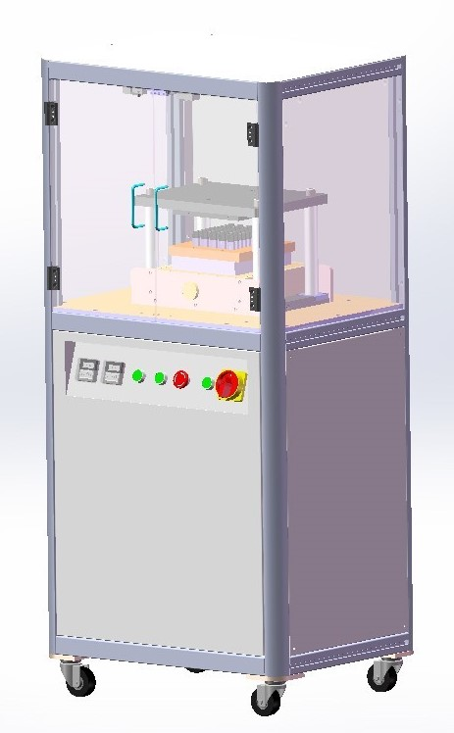
B. Pre-Operation Inspection
- Inspect the NEMA 5-15P to IEC320C13 power plug on the 710Captain to ensure that it is plugged in correctly, is not loose, and is free of any damage.
- Ensure that the 710Captain is plugged into a properly wired and properly grounded AC outlet (NEMA 5-15R, 110v AC, single phase).
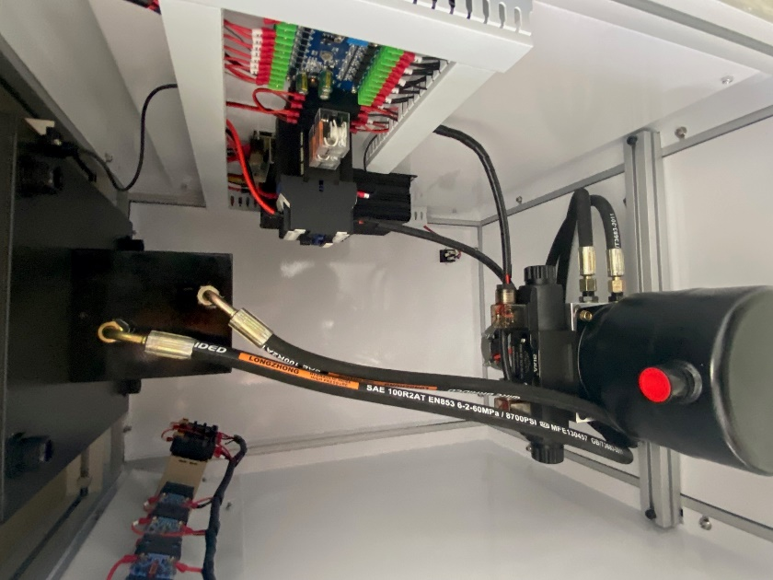
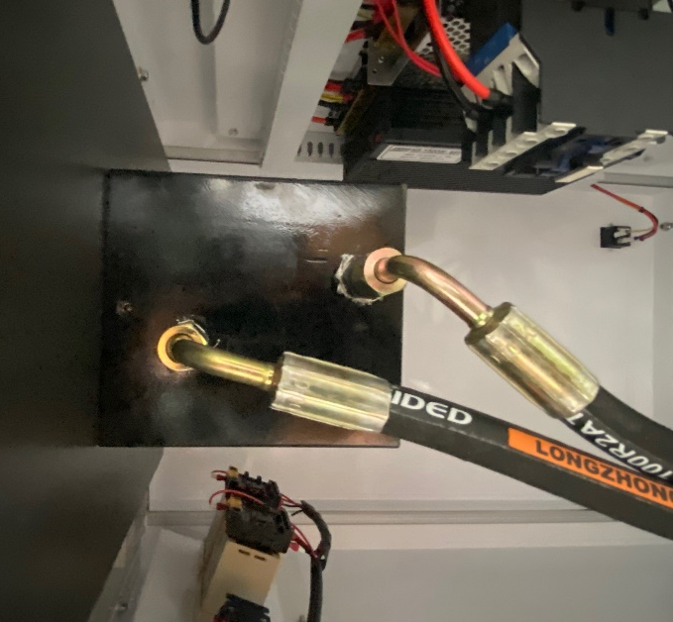
- Inspect for oil leaks in the pipelines of the equipment. To do so, use a screwdriver to remove right side panel to access the oil reservoir. Locate the oil cap (red circle on top of the black cylindrical reservoir) and carefully remove to make sure that the dipstick inside indicates that there’s sufficient oil (~1.8L) before fastening cap back on. Be sure that all connected lines are secure and not leaking any oil. If necessary, use an Allen key #3 to tighten the screw of the vent (small hole above the upper oil line) to prevent future leaks. It is through this vent that oil may be leaking from when machine is shipped or laying on its side during transit. We recommend using synthetic hydraulic oil with viscosity grade 68.
- Inspect the work area before each use. Make sure it is free and clear of any potential hazards.

IV) Operation
After equipment inspection is completed, and everything is normal, power the 710Captain on by turning the power switch a quarter turn clockwise to the ‘ON’ position.

A. Dry Run (no-load operation):
- Begin by ensuring that there is nothing between the top and bottom pressure plates, and that the doors to the 710Captain are closed.
- Press the ALIGN button.
- Observe how the pressing timer will start to count, the top pressure plate will move downwards, and once the time has elapsed, the top pressure plate will halt before rising and returning to its original position. This completes your dry run (no-load operation).
B. Setup Method #1
For combined heights between 125-130mm tall using default PRESS time of 2 seconds
- Using calipers, determine individual height of cartridges, caps, and height plates.
- Rotate the bottom pressure plate adjustment knob counterclockwise so that the bottom pressure plate rests at its lowest point.
- If needed, utilize the included aluminum height plates to get the distance between the top of an already capped cartridge and the pressing height of the top pressure plate to less than 5mm. This means that the combined height of the aluminum height plates, uncapped cartridges, and cartridge caps will need to be between 125-130mm. The 5mm difference between the combined height and the pressing height of the top pressure plate can be adjusted via the bottom pressure plate adjustment knob.

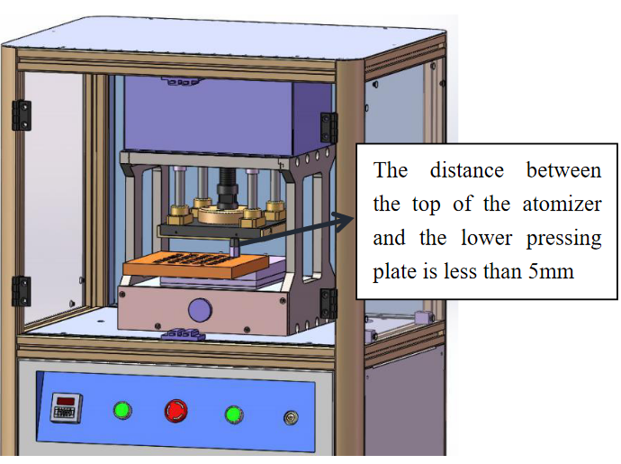
- Once configuration of the top pressure plate has been completed, prepare a jig of filled cartridges with caps, then place them into the 710Captain to be capped.
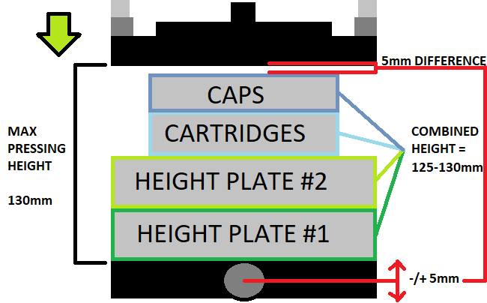
- Press the PRESS button. When the machine begins to operate, observe the top pressure plate when pressing down to determine whether the top pressure plate caps the cartridge. If the cartridge was not completely capped, the bottom pressure plate adjustment knob can be turned clockwise to lift the bottom pressure plate up to 5mm, until the cap of the cartridge is pressed into place.

C. Setup Method #2

Used to determine the correct PRESS time setting for combined heights between 130-175mm tall
- Using calipers, determine combined height of cartridges, caps, and height plates.
- If combined height is between 130-175mm, use the below graph to choose the time setting that does not meet or exceed your combined height.

Example: If your combined height is 150.70mm, the closest PRESS time value without meeting or exceeding that height would be 1.9s, which has an associated pressing height of 151.82mm. This leaves about 1.12mm of space between the top pressure plate and the cartridges, which can be adjusted via the bottom plate adjustment knob (+/-5mm)

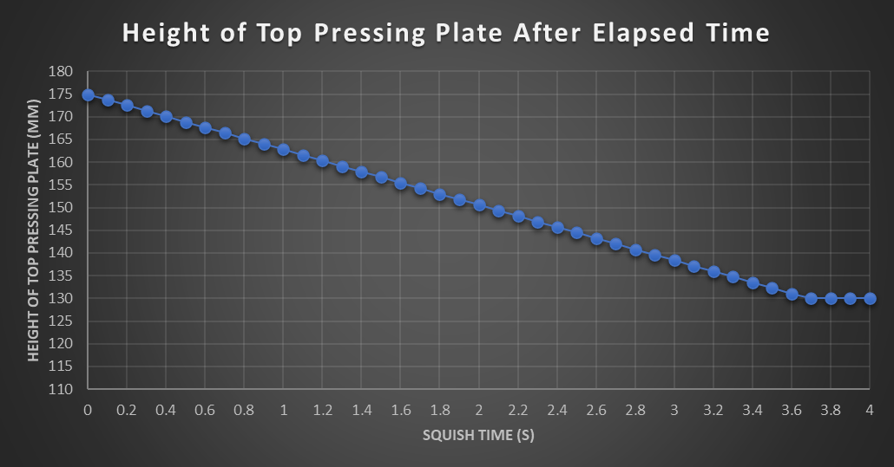
Figure 1: Height of Top Press Plate in Millimeters vs Press Time in Seconds

As shown in the figure to the right, the left side of each timer, outlined in red, is generally NOT used, while the right side, outlined in green, is used. The left timer sets the time interval for the ALIGN button, and the right timer sets the time interval for the PRESS button. The PRESS timer controls the amount of time that the top pressure plate travels downward. Once the time expires, or max pressing height (130mm) is reached, the top pressure plate dwells before automatically rising to the original position. The time setting can be adjusted above and below the number (adjustment keys "+", "-"). The time unit modes available are: "0.1S", "S", "0.1M", "M", "0.1H", and "H" as shown on the right; the time interval can be changed through the up and down of the time unit.
Default setting = [NOT USED 00S | PRESS timer 20 0.1S]

V) Troubleshooting
Issue | Causes | Part Involved | Solution
Main power switch ‘ON,’ no indicator lights illuminated inside pressing area | Power cord is loose or unplugged from machine or electrical outlet | Power supply | Plug in the AC power cord  (NEMA 5-15P to IEC320C13)
 | Blown fuse | Power interface | Replace 5A fuse  (Replacements included)
 | Bad power switch | Power switch | Contact customer support
No functionality when pressing the ALIGN or PRESS button | Emergency STOP button engaged | Emergency Stop Button | Reset the emergency STOP button by turning the button clockwise
 | Door is open, or sensors of the doors are pushed in, out of alignment | 2 Sensors (up top, where doors close on) | Carefully readjust the 2 door sensors so that they protrude slightly forward
 | Control board has malfunctioned | Control board | Contact customer support

VI) System Specifications
Input Voltage | 110VAC 60Hz
Power | 0.8KW
Max Height of Top Pressure Plate | 175mm
Max Travel of Top Pressure Plate | 45mm
Max Pressing Height of Top Pressure Plate | 130mm
Working Pressure | 7500kg
Control | Hydraulic
Size | 650x500x1320mm
Weight | 120kg
Operating Temperature | 10-40℃

For technical support, please email us at engineering@convectium.com
3100 Airway Ave, Suite 138, Costa Mesa, CA 92626

