710Shark Preventative Maintenance
This operations manual describes the processes and procedures necessary to unpack, install, operate, and maintain a pneumatic 710Shark Filling Machine.
*INSTRUCTIONS ARE FOR REFERENCE ONLY*
Scheduling a remote installation and training session with Convectium support prior to operation is required. The below procedures should never be performed without consulting with a Convectium representative first. Failure to do so may void your warranty. Please email engineering@convectium.com to set up an appointment.

I) Proper Removal & Disassembling of the Injector Head
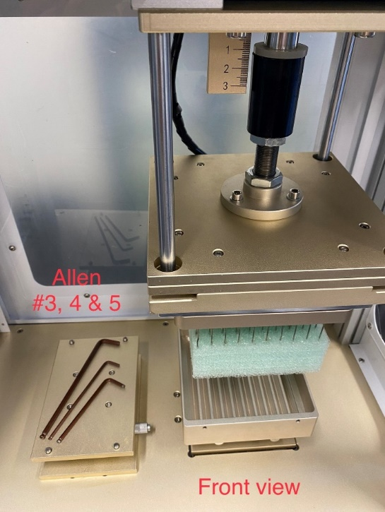
A. Prep & Safety
1. For your safety, turn off power and disconnect air from the 710Shark before attempting to dismantle the injector head. WARNING! Failure to do so may result in electrocution and or damage to the injector head.
a. Place foam block over the tips of the needles for safety and to protect from damage. This also serves to hold all needles in place upon removal.
b. You will need to get an Allen key set and crescent wrench. (Allen key set is included in the Accessory Box).
2. From the back of the 710Shark, locate the 2 heating elements (rods) and the silver thermocouple located in the back of the injector head. Use an 8mm crescent wrench to carefully remove nut that holds the thermocouple in place.
a. Carefully disconnect all 3 and keep them safely out of the way. You don’t want them to get snagged and damaged when the time comes to remove the injector head. (See pics below).
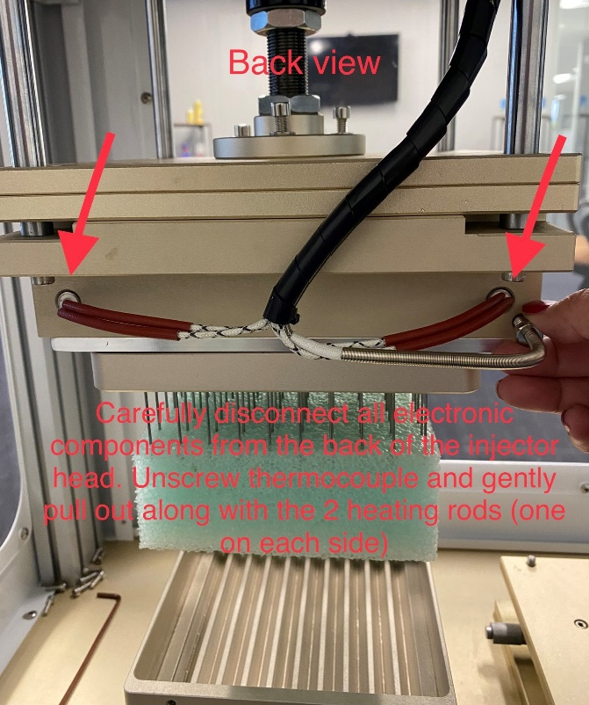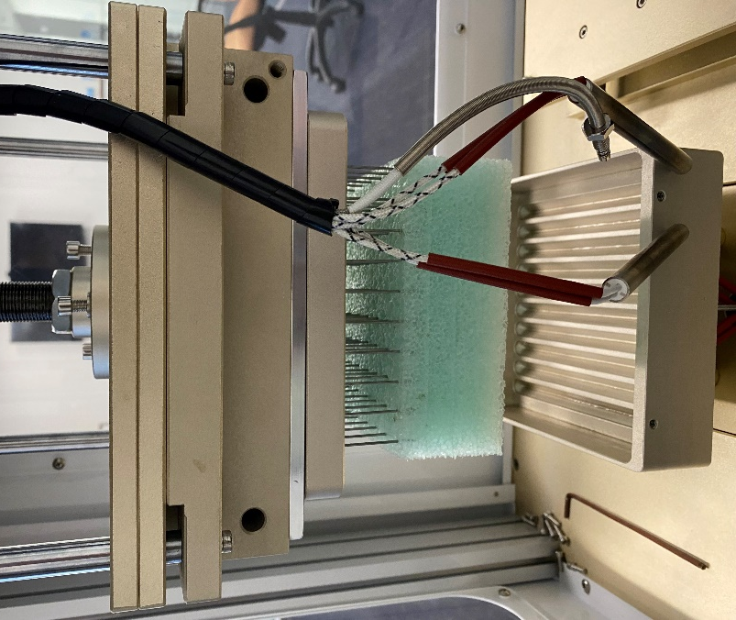

B. Secure Injector Head Before Removal with Jack Support
1. Using the oil basin platform as a jack, manually adjust the height of the oil basin piston to get it as far up as possible to secure the weight of the injector head. Alternatively, you can use a lab jack in place of the oil basin on its platform to support the injector head.
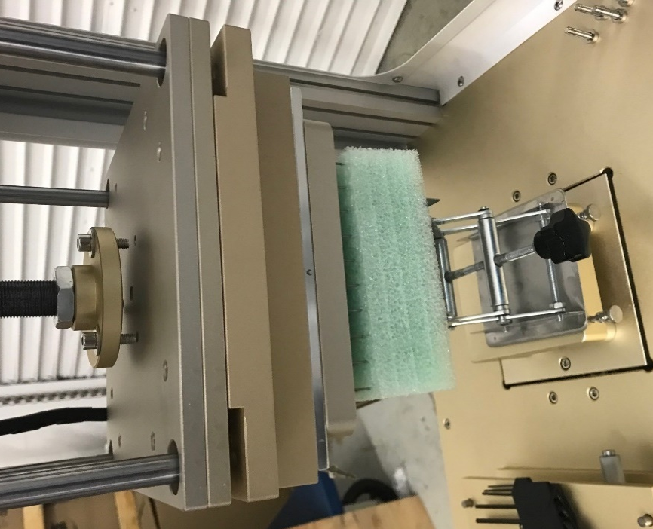
a. If attempting to do this solo, you may want use bungee cords to help hold the injector head up, as well as using a jack. The idea is to support the weight of the injector head as you remove the bolts to dismantle; you want to avoid it dropping unevenly and causing damage to the threading of the bolts.
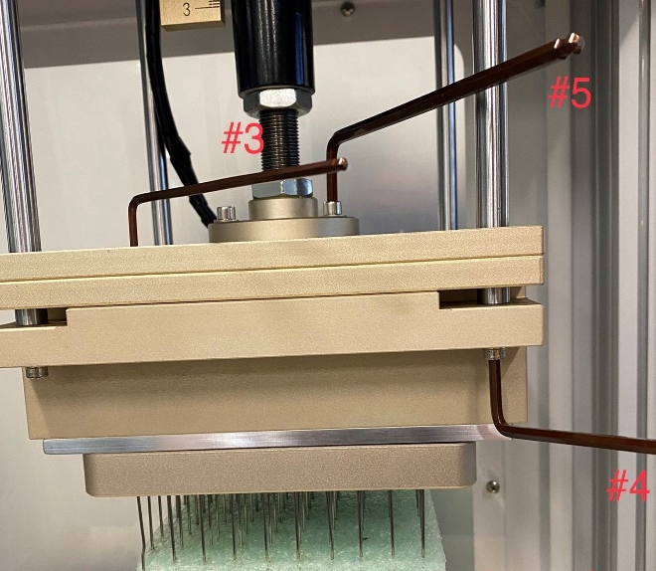
2. Once injector head is secure, use the Allen keys accordingly to remove all bolts. Remember to do so in a balanced fashion (across from each other like when removing a tire). Start with the four medium bolts found underneath each of the four corners of the injector head (#4), then remove the three bigger bolts on the round flange on top (#5).

3. Once all bolts are removed, carefully lower the jack to allow the oil basin cradling the injector head to drop down for removal.

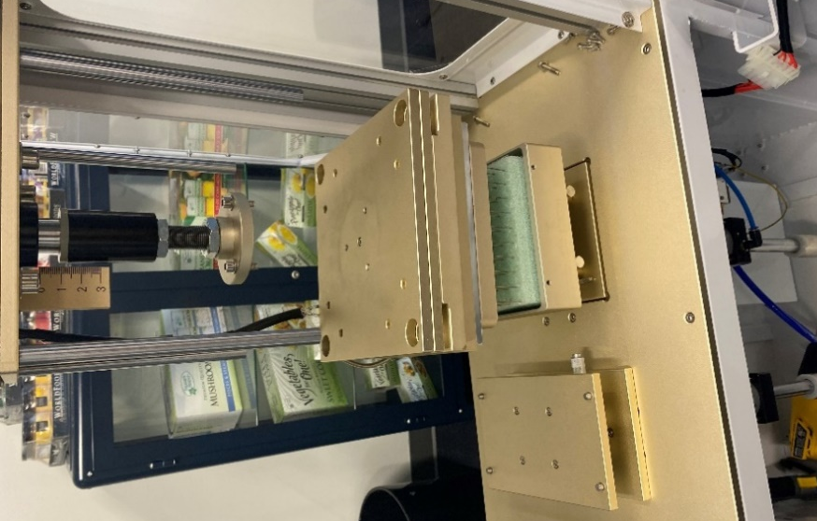
a. Be sure to invert (flip upside down) injector head when setting onto a flat, clean tabletop surface to perform needle/gasket changes. This is to alleviate weight off the needles in the foam, to protect the tips of the needles. (It’s also to better access the bolts that hold the injector head plates together).

4. To access the inner layers of the injector head, remove the smaller nine screws (with Allen #3) to remove the top plate. From top to bottom, the plates are stacked as followed:
a. plunger plate cover
b. plunger plate
c. lower reservoir plate
d. gasket retaining plate
e. needle plate
TIP: When changing out needles, take note of the orientation of the needle itself as well as the needle array pattern. If looking to replace just a single needle, be sure to flag it by marker, Post-It tab, string, or any other way to identify it prior to placing the foam block over the tips before removing the injector head.
II) Changing Needles
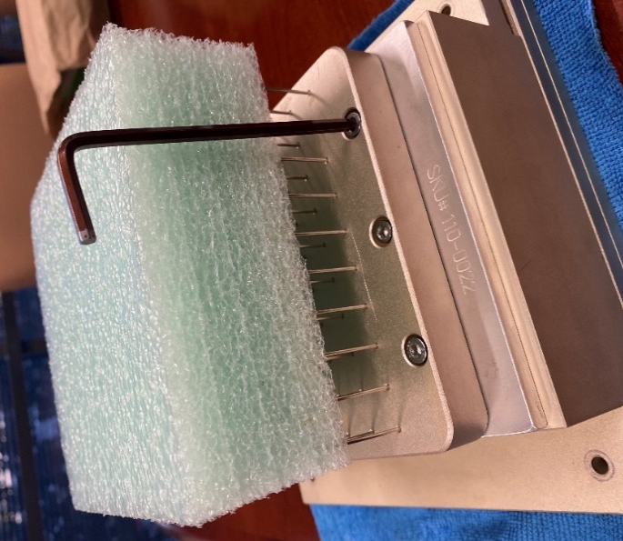
1. With the injector head removed and inverted so that needle foam is up, locate the six bolts (three on each side of the needle plate) and carefully remove them with a #4 Allen key in a balanced fashion.
a. You may need a spray bottle of isopropyl alcohol to help dissolve any residual oil that may prevent you from easily taking the needle plate apart from the rest of the injector head. Using a flathead screwdriver may help, too, but keep in mind plates are made of aluminum and using excess force may cause superficial scratches to the surfaces.
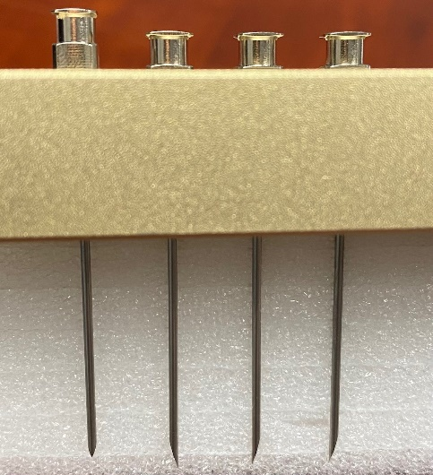
b. To replace a single needle, we suggest using a marker or little tab stickers to easily identify the damaged needle prior. Otherwise, you may replace all the needles if necessary. Carefully remove the needle plate, along with the needles still intact to the foam block, by flipping it so the needles are now at the bottom, exposing the tracks that the needles are embedded in on the other side of the needle plate.
c. Notice that the tracks are made so that the needles can only sit flush inside of the tracks accordingly. Turn the needles a quarter turn if they don’t sit flush but be sure that all tapered needles are facing the same way. (You may need to turn them 180 to get them to sit flush and facing the same way). This is so that tapered needles are oriented in uniform fashion, which will affect the performance of injection when filling. (This is not as important for blunt needles).

III) Changing Gaskets
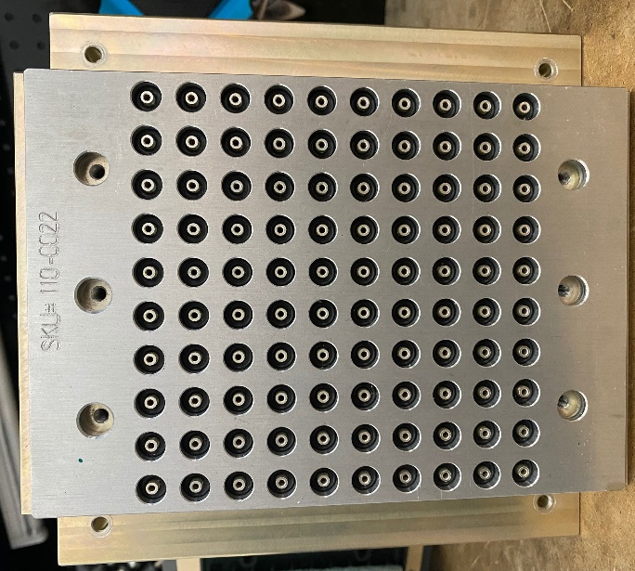
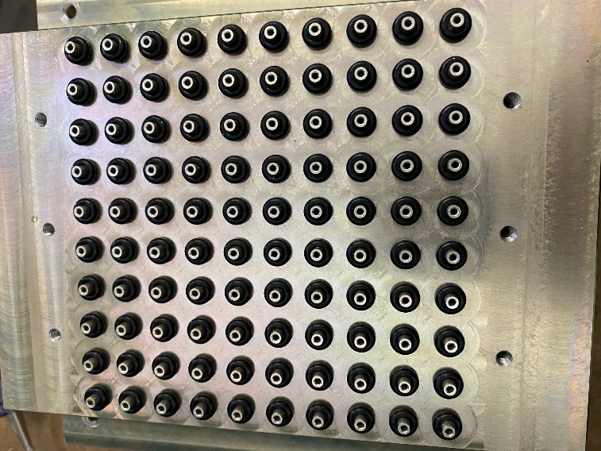
1. While you are changing needles, it’s good practice to take the time to check the conditions of the black gaskets as well. Remove the silver (gasket retaining) plate to expose the gaskets and look for any broken or otherwise damaged ones. Replace with new gaskets (that are included in the Accessory Box or may be purchased from Convectium).

2. Once damaged gaskets are replaced, place gasket retaining plate back on prior to assembling needle plate back on. Secure plates together with the six longer M4 screws (4.5mm diam, 0.8mm pitch) to complete the injector head assembly. Remember to not over torque and to fasten in a balanced fashion (across from each other like balancing a tire).

IV) Preventative Maintenance of Plungers (Cleaning, Lubing & Changing of O-rings)
1. It’s very rare to have to change out or clean plungers but since you’ve already disassembled the injector head you may want to check to see whether there’s any residual oil or blockage to the cylinders of the plunger plate (the thickest plate of the injector head that house the plungers), as well as any damage to the 2 clear o-rings on the ends of each plunger. Replace any damaged o-rings with the replacements that came in the Accessory Box (or purchase some from Convectium directly).
2. We recommend using 91-99% isopropyl alcohol to clean any parts of the 710Shark and drying with a lint-free wipe or cloth. Avoid using acetone which may strip the coating of the parts.
a. TIP: use foam or cardboard on your work surface to protect the nozzles on the underside of the lower reservoir plate (where the black gaskets go). This is to avoid damage that may cause blockage.
3. Use a small spout cleaning brush to clean the cylinders if necessary and use compressed air to air dry any residue out of the cylinders.
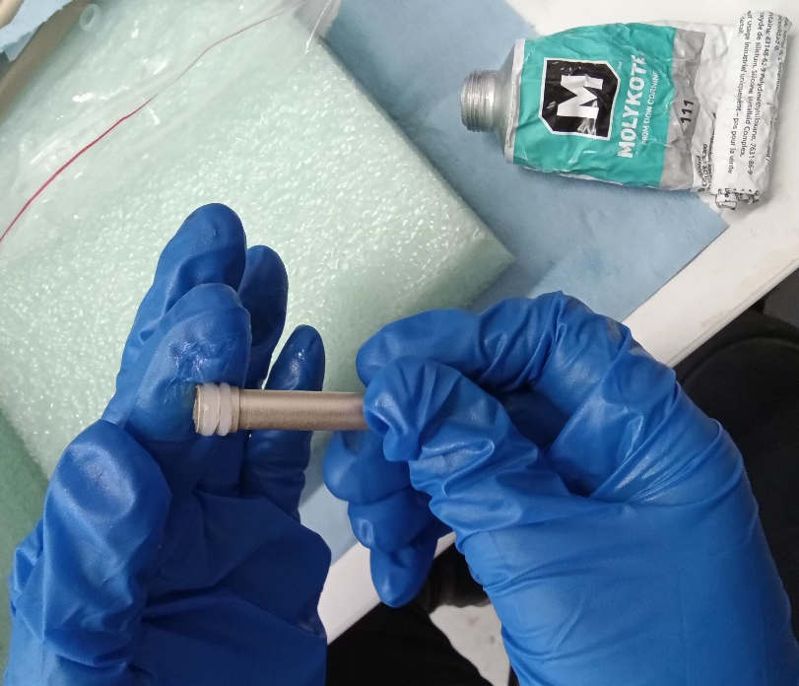
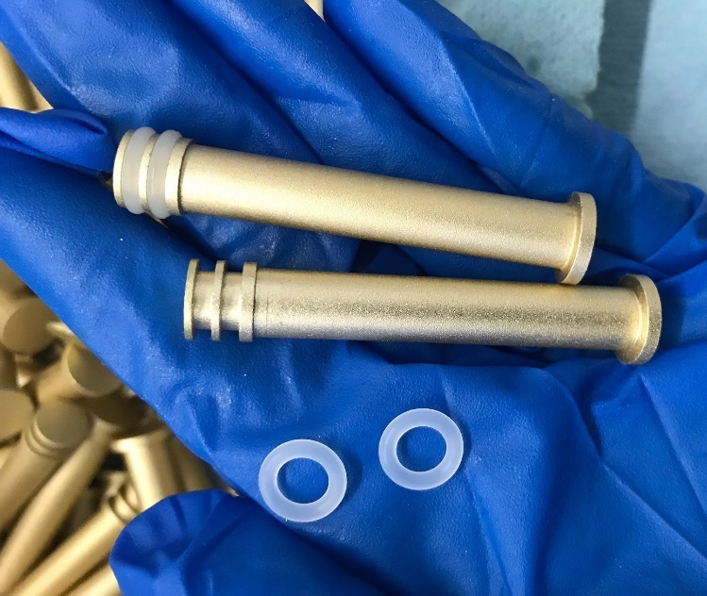
4. Before placing each clean plunger back into the plunger plate, use Molykote 111 food safe silicone grease SPARINGLY as a thin layer around the o-rings only (avoid excessive amounts on the ends and down the shaft of each cylinder). The idea is to ensure a proper seal without contaminating your products with excess Molykote.

a. Make sure all cylinders are clean and dry, plungers are clean, dry, lubed and sitting flush all the way inside the plunger plate before assembling the injector head back together.

V) Proper Assembling & Installation of the Injector Head
1. The objective to properly assemble the injector head is to do so with zero to minimal damage to the components, particularly with the screws without stripping them, so that it sits squarely back on its track of pistons. You should not be able to see light coming through between any of the plates that stack on top of one another in the injector head. They should all be flush and square, using a level once mounted is suggested.
a. In the reverse order in which you disassembled, start by making sure all components are in their proper place before screwing in the longer 6 bolts (3 on each side) of the needle plate. Tighten in a balanced fashion across from each other, remember to fasten until all plates are airtight, but do NOT over torque to avoid striping.
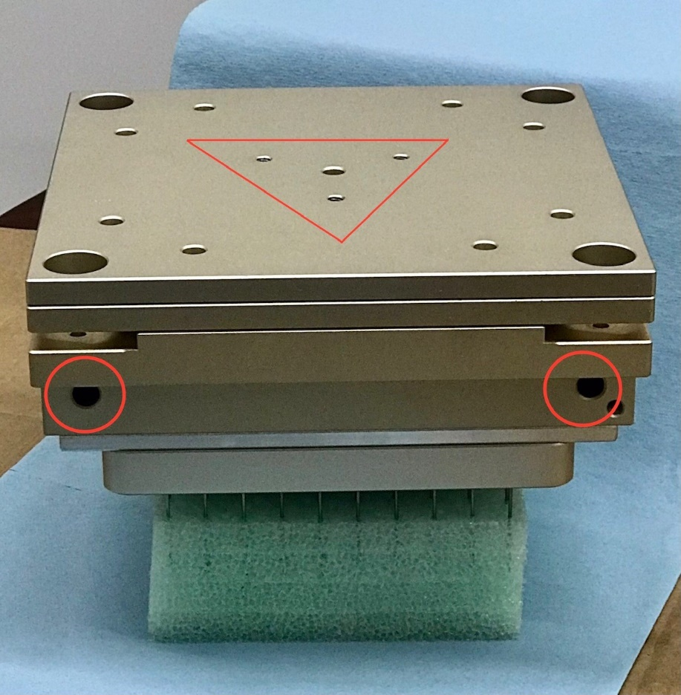
b. Now carefully invert the whole stack over and make sure the top plate is oriented in the correct placement before screwing in the smaller bolts with the Allen key #3 (there should 9 total, 1 in the center and 4 pairs near the 4 posts).
c. Notice that the two holes for the heating element rods should be oriented to the back of the 710Shark. Make sure that the top plate is oriented so that the triangle pattern is also pointed to the back (see picture below).
2. Using the oil basin platform as a jack (or a lab jack directly on the oil basin platform), carefully invert the injector head right side up and place it on top of the platform so that the back side is facing the back and the screw holes within the triangle are lined up to the top round flange. Using the Allen key #5 screw those three bolts back in.
3. Using the Allen key #4 screw in the four bolts from the bottom of each of the four corner posts.
a. Remember to do so in a balanced fashion, moving across to achieve a square mount. Using a bubble level will ensure proper mounting.
b. Be sure to not over torque as it may strip the injector head. Power tools are not recommended for this reason.
3. Carefully install the electronic components back into the backside of the injector head (two heating rods and one thermocouple), ensuring that none of the wiring has been cut/damaged during the install. WARNING! Exposed or cut wires may spark and cause electrocution or fire.
4. Once fully assembled, plug air hose and power cord back into the 710Shark and power on to check electrical function. Be sure to recalibrate and check for alignment first before proceeding in a production run.

For further technical support, email engineering@convectium.com
3100 Airway Ave, Suite 138, Costa Mesa, CA 92626

